**Assignment#1**

**2015311901**

**Junho Bae**

**Computer Networks**

1. **Development environments**
   1. **OS**

* I feel more familiar with Windows OS. Therefore, first I designed program in Windows10 with python3, then I tested my program in Oracle VirtualBox and Ubuntu(16.04.7) with Python3

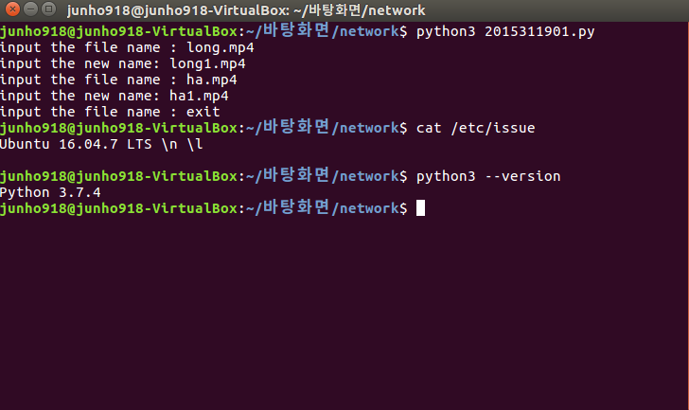

* There were some diffrnece between Windows and Ubuntu while reading file directory. So, I slightly editied the program to run properly in Ubuntu environment**.**
* I also make sure that I did not used some libraries which is only dedicated for Windows OS.

1. **How I designed assginment(data structures, algorithms)**

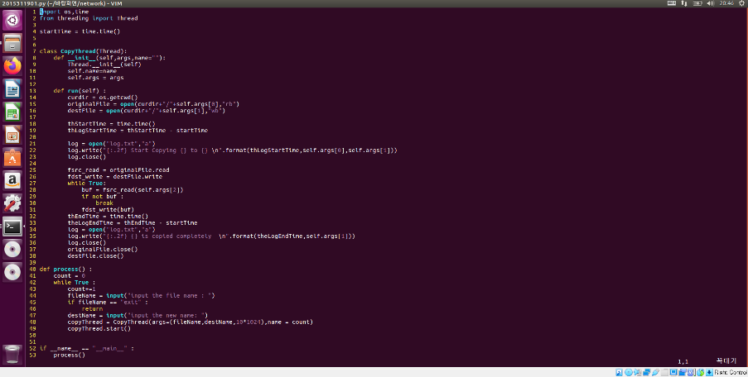

* If screesnshot is too small, please check my source file.
* I implemented “CopyThread” class which inherits ‘threading.Thread’ so that I can implement multi threading program. The CopyThread class requires three arguments, source file name, destination file name, and length. I gave length argument as 1024*10 which means 10kb instructed in assignment notice. Therefore, program will read 10Kb of source file with buffer and write buffer into the new destination file during the loop.
* In CopyThread, “run” method is implemented which will run after calling thread.start().
* The program will be terminated when input in console is “exit”.
* Each time program gets input(source file name, destination file name), it will create each instance of thread.
* Threads run individually.

1. **How I tested my program**

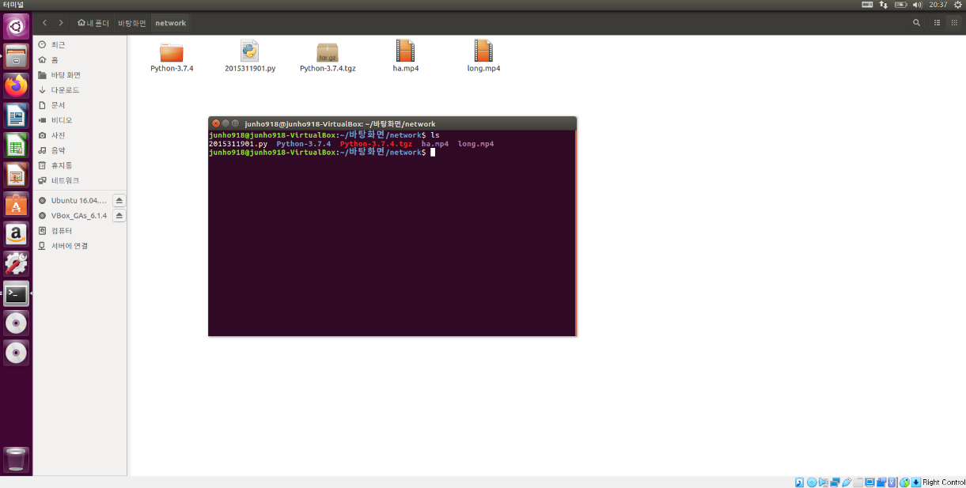

* There are two video files(long.mp4, ha.mp4). long.mp4 has 1.2GB size and ha.mp4 has 57.2MB which is lighter than long.mp4.

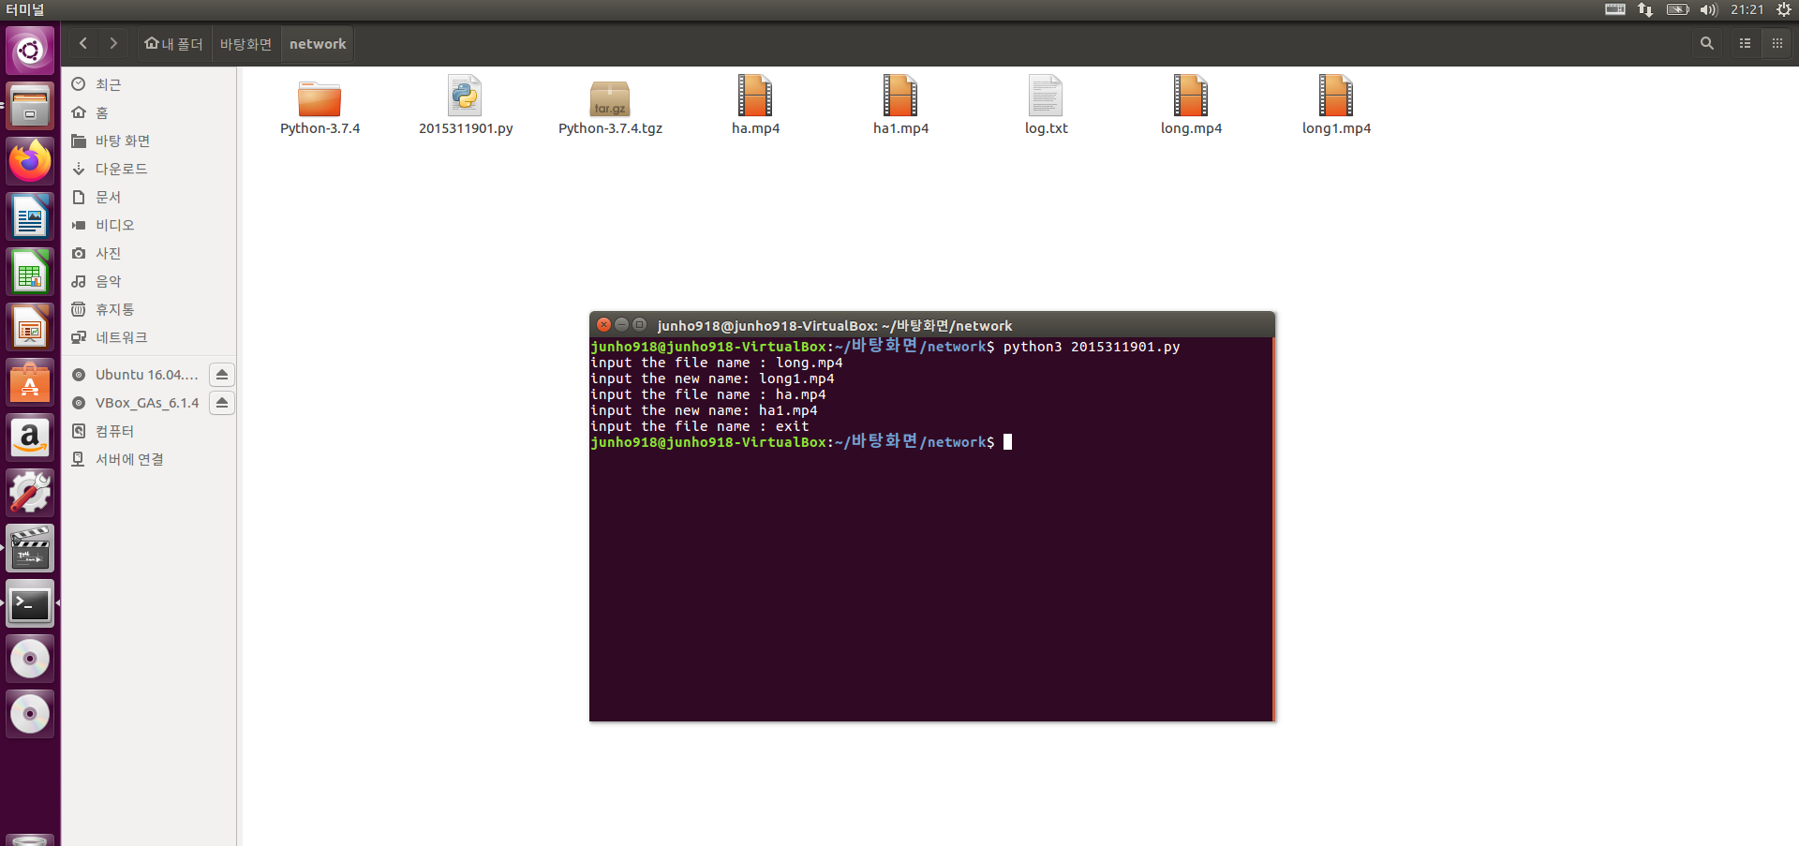

* If I run the program with command “python3 2015311901.py” then program will run.
* I can give inputs with command line. The program will run until first input is “exit”.
* We can see there are three outputs. long1.mp4,ha1.mp4 those are the copies of original files. Log.txt is for the logs of program.
* Please run program with command “python3”
* If inputs are text, then command line input does not need “.txt” extension While other object(mp4, jpg) needs extension.

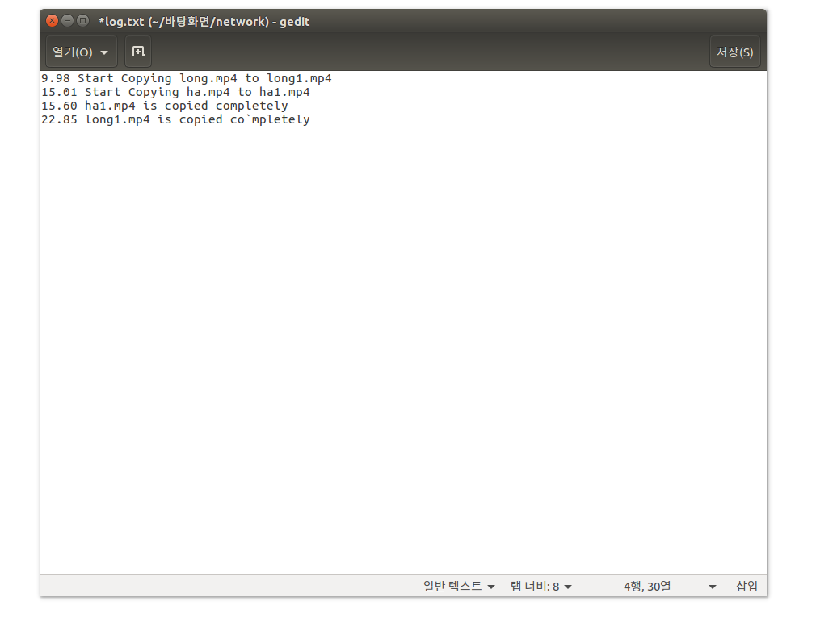

* In the log.txt, though copying long.mp4 process started first, copying ha.mp4 process ended first because long.mp4 is much larger than ha.mp4

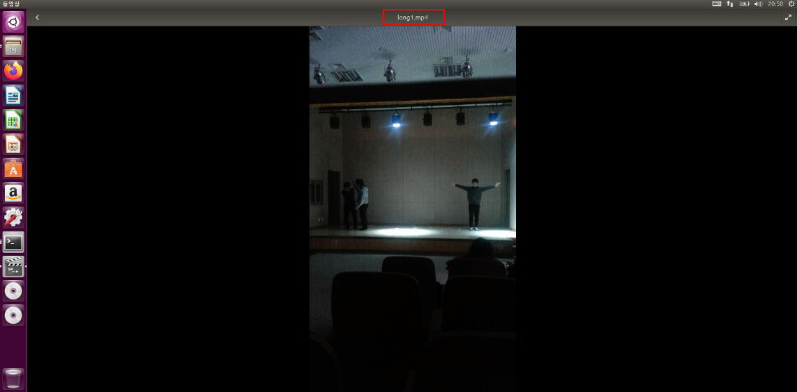

* Also, I can see that copied file can be played properly.